1. Provisioning EC2 instances (Ex: 1 master 2 nodes)

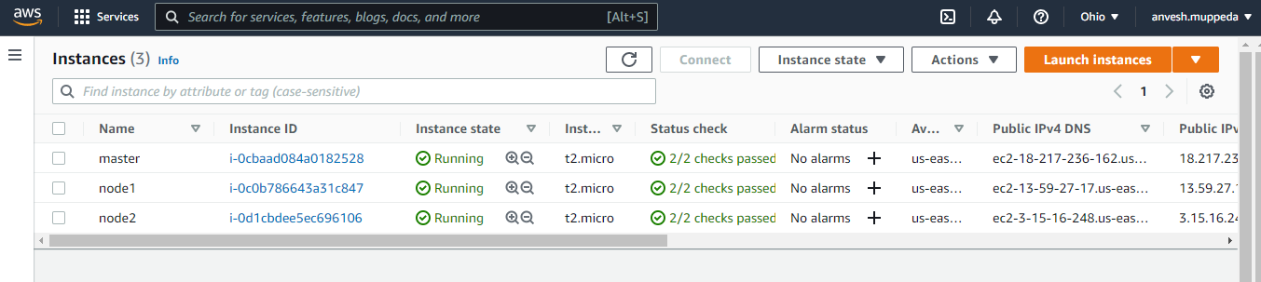

2. Install Python (Here it's inbuilt feature as we launched the linux instances)



3. Install Ansible on the master node as root user.

sudo su

yum install ansible -y

sudo amazon-linux-extras install ansible2 (due to different operating systems we use this)

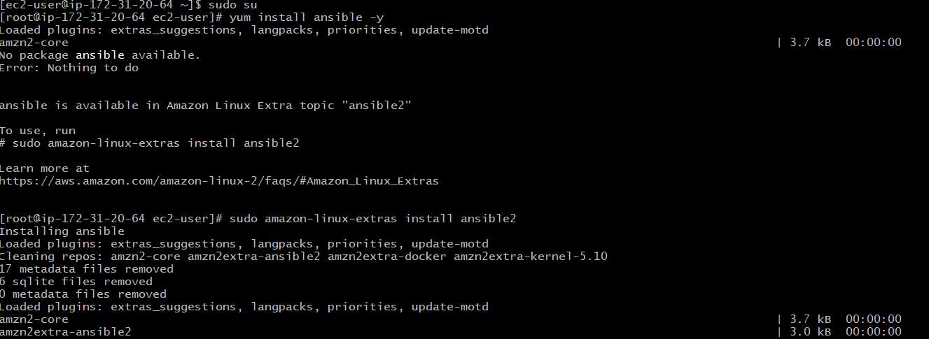

4. Add common user (this user performs tasks on all the nodes) on all the machines as root user.

sudo su

adduser user_name

passwd *******

Enter new password ********

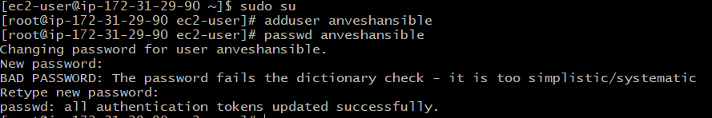

To know the list of all the users present on the machine - compgen -u

Ansible version on master node:

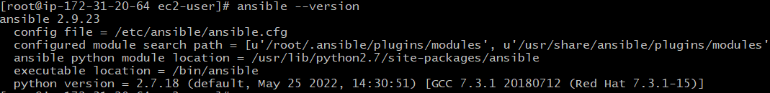

5. Need to grant permissions to the created common user to perform the desired tasks using - "visudo" command and make the required changes.

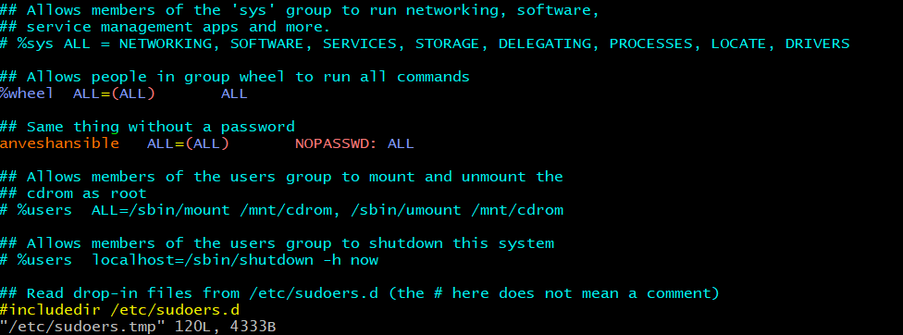

6. Need to enable password authentication to connect to the instance as the common user.

vim /etc/ssh/sshd_config

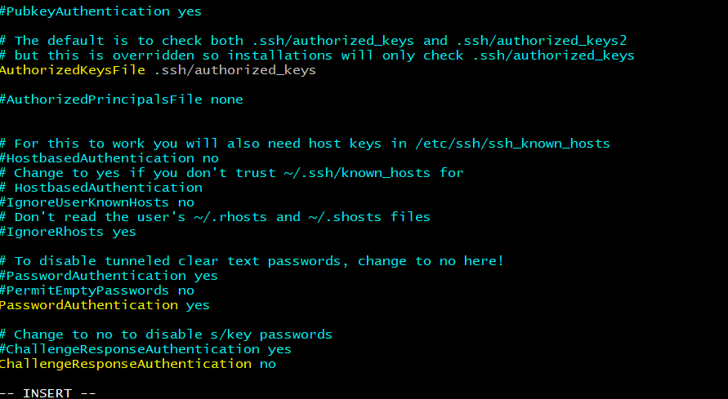

Make the required changes and restart the service.

service sshd reload

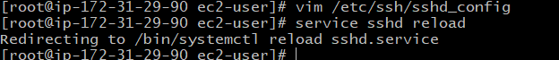

After all the above changes need to be done on all the instances, make sure you are able to connect using the common user.

